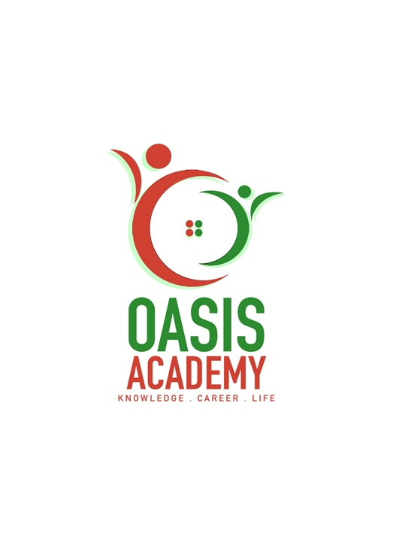

**Name : Uwarajan Anthinari**

**Login ID :** [**uwarajan@oasis-portal.com**](mailto:uwarajan@oasis-portal.com)

**Course Tittle : Tourism And Hospitality**

**Subject Code : BHM04**

**Submitted Date : 19 Sept 2017**

**Table Of Contents**

|  |  |  |
| --- | --- | --- |
| **No** | **Details** | **Page** |
| 1 | Executive Summary | **2** |
| 2 | Introduction | **3** |
| 3 | Assignment Question |  |
|  | Question 1 | **4-5** |
|  | Question 2 | **6 - 8** |
|  | Question 3 | **9 - 11** |
|  | Question 4 | **12 - 13** |
| 4 | Conclusion | **14** |
| 5 | References | **15** |
| 6 | Appendix | **16 - 17** |

**1**

**Executive Summary**

In the module, i covered the topic about Tourism and Hospitality. In first part, we can learnt about introduction of toursim and hospitality. From that we can know more details about tourism and hospitality. First of all, we start from define the tourism and hospitality and explain what we understand about hospitality industry. After that, we continue with brief on different type of tourism categories and define tourism. Besides that, we can understood more about that. Furthermore, we must knows about concept of loadging and accommodation in hospitality industry because its most important in hospitality industry. The next question is describe the lodging accommodation and types of hotel accommodation. From this we can learnt different types of hotel accommodation. Last and least, explain the significant of entertainment in this industry. There are many entertainment things, such as drama, music, dance,reading,sport and more. Entertainment is not served as means of entertaining any more, if we are aware of the benefits that we can gain from it.

**2**

**Introduction**

Tourism and hospitality go hand in hand. Tourism and hospitality are among the world’s fastest growing industries that employ more than 60 million people worldwide. The opportunity for an exciting and interesting career is enormous with hospitality and tourism sector. Tourism helps in the growth of economy of a country. Hospitality basically means providing services and demonstrating consistent excellence and quality. The hospitality and tourism industry is diverse, and includes many locations including RV parks, food establishments, recreational facilities, campgrounds, boarding houses and youth hostels. While the overall goal of a hospitality professional is to ensure that guests and customers have pleasurable experiences, they can also be responsible for operations, such as hiring and training new staff; supervising office and financial administration; housekeeping, maintenance, and security staff; and marketing.

Hospitality professionals also distribute funds, set room rates, and ensure that the service standars of the business are met. General duties for hospitality professionals very depending on the size of the business and the amount of staff available. In larger operations, there is usually a hierarchy of general managers, assistant managers, and supervisors who work to perform operational tasks relating to thier areas of expertise. In a smaller business, the hospitality professional performs these tasks directly.

Sometimes hospitality professional positions are specialized. For example, some focus on managing the front office, while others can be responsible for convention services or financial administraction. If a hospitality professional is employed in a specialized position, he or she must have excellent communication skills and the ability to work well alongside coworkers in other areas of the business.

Another important factor is advanced technology sevices. Customers have to feel that all information regarding the place that they visit is at their fingertips and easy accessibility is an added advantage. Tourism and hospitality is a great and vast sector with lost growth opportunities and also opportunities in revenue earning. One must see to it that their customers are made to feel at home, when at a new place.

**3**

**Assignment Questions**

**Question 1**

**Define the Tourism and Hospitality.**

**Explain your understanding about Hospitality Industry.**

Meaning of Tourism is travelling for recreational, leisure, family or business purposes, usually for a duration.Tourism is mainly associated with trans national level, but may also refer to travel to another location within the same country. It is important to preserve and protect our natural resources, culture and traditions and for this tourism is a vital factor. Tourism is not only concerned with the movement of people but also includes various other service providing agencies. The movement of people is temporary in nature as it goes up to a maximum of 1 year, but the impact on allied service industry is long lasting, which gives a boost to the economy, creating job opportunities.

The term Tourism is defined in many ways and there is no consensus regarding the difinition of tourism. Tour is derived from Latin “ tornare “ and the Greek tornos” meaning the movement around a central point or axis of a circle. Suffix ‘ism’ defined as an action or a process made it to mean a journey from one point to complete a circle in the process. Tourism is also defined as a collection of activities, services and industries which deliver a travel experience comprising transportation, accomodation, shopping, entertainment and hospitality to travellers away from home. The dictionary meaning of tourism makes us to believe it as a travel for recreation, leisure or business purposes.

**4**

The word hospitality derives from the Latin hospes, which is formed from hostis, which originally meant a ‘stanger’ (hostilis) + pets (polis,poles,potentia) to have power. Furthermore, the word hostire means equilize/ compensate. Define of Hospitality is the hospitality industry consists of broad category of fields within the service industry that includes lodging, restaurants, event planning, theme parks, transportation, cruise line, and additional fields within the tourism industry. The hospitality industry is a several billion dollar industry that mostly depends on the availability of leisure time and disposable income. A hospitality unit such as a restaurant, hotel, or even an amusement park consists of multiple groups such as facility maintenance, direct operations (servers, housekeepers,porters,kitchen workers, bartenders), management, marketing, and human resources.

Tourism has become an important sector that has an impact on development of country economy. The main benefits of tourism are income creation and generation of jobs. For many regions and countries it is the most important source of welfare. Tourism is an important, even vital, source of income for many regions and countries. Tourism brings in large amounts of income into a local economy in the form of payment for goods and services needed by tourists, accounting for 30% of the world’s trade of services, and 6% of overall exports of goods and services.

**5**

**Question 2**

**Brief on different type of Tourism categories.**

**Define Tourism.**

A group of interrelated, inteedependent and interacting three basic elements . such as, tourists, geographical elemets (traveller generating region, tourist destination region and transit route region) and tourism industry that together from a single functional structure. Applying a set of geographical criteria to understand the reasons by grouping them into similar categories, including Spiritual factors related to the shared characteristic of a group of people . Historical factors related to the past experiences and events. By classifying places we can better understand important interconnections to place.

Tourism is travel for pleasure or business; also the theory and practice of touring, the business of attacting, accommodating, and entertaining tourists, and the business of operating tours. Tourism maybe international, or within the traveller’s country. The World Tourism Organization defines tourism more generally, in terms which go “ beyond the common perception of tourism as being limited to holiday activity only” as people “ traveling to and staying in places outside thier usual environment for not more than one consecutive year for leisure, business and other purposes.

Tourism can be domestic or international, and international tourism has both incoming and outgoing implications on a country’s balance of payment. Today, tourism is a major source of income for many countries, and affects the economy of both the source and host countries, in some cases being of vital importance.

The tourism product can be defined as the sum of the physical and psychological satisfaction it provides to tourists during their travelling en route to the destination. The tourist product focuses on facilities and services designed to meet the needs of the tourist. It can be seen as a comcomposite product, as the sum total of a country’s tourist attractions,transport, and accommodation and of entertainment which result in customer satisfaction. Each of the components of a tourist product can be annalysed in terms of its attraction, accessibility and accommondation.

**6**

Futhermore, if the objective of one’s visit to a particular place is to get to know its history and culture then this type of tourism is known as cultural tourism. Tourists may visit different landmarks of a particular country or they may simply opt to focus on just one area. They may also attend festivals and ceremonies in order to gain a better understanding of the people, thier beliefs and thier practices. Religious tourism is another type of tourism where people go to a religious location or locations to follow the footsteps of thier founder or to attend a religious ceremony. Catholics, for example, go on pilgrimages in the Holy Land to experience the paths where Jesus walked. Called sports tourism, travelers here target places which are known for a particular sporting facility. Skiing, for example, is a type of sports tourism. Also included in this categeory are those who go to a destination to experience a sports spectacle such as the Olumpics,FIFA World Cup and others.

**7**

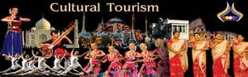

**Cultural Tourism**

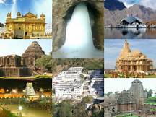

**Religious Tourism**



**Sports Tourism**

**8**

**Question 3**

**Describe the lodging accommodation and types of hotel accommodation.**

In the hospitality sector, the success of a business depends largely on how efficient the hospitality team is and how effective the business model is. So, in essence, one can make a foray into all categories of the hospitality industry. There are 5 different sectors of the hospitality industry. Such as, lodging accommodation, food and beverage, travel and tourism, entertainment industry, and timeshare.

Loadging sector of the hospitality industry features a gamut from luxurious hotels to lavish resorts and campgrounds. Accommodation is an absolutely broad sector of the hospitality industry, ranging from bed & breakfast enterprises and hotels to other facilities that offer lodging services.

Food and beverage is another crucial one among the 5 different sectors of the hospitality industry. It’s another wide sector of the hospitality industry. Food and beverage sector regin supreme in the industry. And for good reasons, it can range from something as simple as a bistro all the way to a high- end restaurant and evey catering establishment in between. As it’s expected, food and beverage industry is further sub-categorized into niches. There can be a humongous list when we categorize food service industry as a crucial sector of hospitality industry but we will list the key categories such as, quick-service establishments, catering businesses and full-service restaurants.

A lot consider tourism synonymous to hospitality and not as a different sector of the hospitality industry. Travel and tourism industry is a vast sector of the hospitality industry

with several key players across the globe. Most of them include trains, airliness, cruise ships, and several crew members in thier service. On the whole, players in travel and tourism segment are in the business of moving people from one destination to another. Like all other different sectors of the hospitality industry, this one also demands customers focus, leniency, relationship management, and other integrated marketing skills for its smooth running and expansion.

**9**

Entertainment industry is a key category of the hospitality industry as it involves the most important thing of hospitality. Us, the buyers and recipents of all hospitality services. So, this sector of hospitality thrives for us and to entertain us. Entertainment is a significant part of our travel these days. If your travelling experience lacks fun and entertainment then you might not be able to enjoy your time up to the fullest. Some of the activities which can elevate your experience when it comes to entertainment are Marinas, Sports and Gaming, Cruise, Nightclubs, and Bars.

Timeshare is an emerging yet vastly important sector of the hospitality industry is vaction ownership of a place. In this scheme, people, either individuals or parties, own the rights to a place for a specific time period during the year. We have placed in our 5 different sectors of the hospitality industry because of the raise interest of hospitality enthusiasts for timeshare. Timeshare gives us an option to own our choices and to enjoy facilities by either buying a part of a facility or getting into a membership plan.

Lodging accommodation services when people travel from one place to the other, they need a place to sleep. A shelter which will keep them safe from the atrocities of nature. This results in people booking loadges and rooms for thier stay. Sultes are apart from general loadges to stay, hotel sector offers luxury suites for the stay as well. Generally, suites are suitable for formal sorts of staying and are much expensive compared to regular room services. The third type of accommodation which is popular among travellers are resorts. These bring you close to nature and give you a necessary break from your normal routines.

There are different between hotel and hostel, cottage and chalet, or yurt and tent, we’ve compiled a comprehensive list of 52 different types of accommodation in tourism. They fall into many categories and vary widely in size, style, services, and characteristics, sometimes from one country to another, and sometimes from city to countryside.

**10**

Love hotel is a category of hotels that offer short stays for couples looking to engage in sexual activities. Love hotels are particulary popular in Japan. Aparthotel is a smart choice for longterm accommodation, aparthotels or apartment hotels combine the comfort and independence of a private apartment with the services of a hotel. Eco hotel is an environmentally friendly accommodation aiming to promote sustainable torism and green living through the use of renewable energy sources, recycled materials, and organic locally-sourced produce. Their philosophy is to minimize the impact on the environment. Furthermore, design hotel is a stylish and intimate hotel with an emphasis on design, service, and luxury facilities. Their rooms are exquisitely decorated and often packed with the latest technology features.

**11**

**Question 4**

**Explain the Significant of Entertainment in this industry**

Entertainment is a form of activity that holds the attention and interest of an audience, or gives pleasure and delight.. It’s is any kind of activity that provides amusement for people in a passive way. It can be an idea or a task, but is more likely to be one of the activities or events that have developed over thousands of years specifically for the purpose of keeping an audience’s attention. Although people’s attention is held by different things, because individuals have different preferences in entertainment, most forms are recognisable and familar. Storytelling, music, drama, dance, and different kinds of performance exist in all cultures, were supported in royal courts, developed into sophisticated forms and over time became availble to all citizens.

The experience of being entertained has come to be strongly associated with amusement, so that one common understanding of the idea is fun and laughter, although many entertainment have a serious purpose. This may be the case in the various forms of ceremony, celebration, religious festival, or satire for example. Hence, there is the possibility that what appears as entertainment may also be a means of achieving insight or intellectual growth.

There are many types of entertainment for particular tastes, for example we have cinema, theatre, sports, games, social dance, concert, comedy shows, animations, impressionists, clowns and the list goes on and on.

Music is a supporting component of many kinds of entertainment and most kinds of performance. Music is also a universal and popular type of entertainment on its own, constituting an entire performance such as when concerts are given. Reading also has been a source of entertainment for a very long time, especially when other forms. Such as performance entertainments, wew (or are ) either unavailable or too costly. Among literature’s many gerves are some designed in whole or in part, purely for entertainment.

**12**

The evolution of an activity into a sport and then an entertainment is also affected by the local climate and conditions. For example, the modern sport of surfing is associated with Hawaii and that of snow skiing probably evolved in Scandinavia.

As a form of spectacle and enterinment, expositions influenced “ everything from architecture, to patterns of globalisation, to fundamental matters of human identity” and in the process estaclished the close relationship between “fairs, the rise of department stores and art museums”, the modern world of mass consumption and the entertainment industry.

In conclusion, entertainment is not served as means of entertaining any more, if we are aware of the benefits that we can gain from it.

**13**

**Conclusation**

The travel and tourism that going to carry on also should be suitable for the season. Because the customers are always like to travel to different destination in different season. So should carry on the correct travel and tourism event at the correct season. If not it will affect all the industry. The customer may not will support the agency because they are not giving what they want and they wont’t satisfy with them at all. At last the food and beverage also will affect the industry, even is not a big issue and important in a travel and tourism industry. The foods they provide to the customers should be good foods which is not expired and spoiled. So if a tourism industry wants be success means, they should consider all the element of the travel and tourism. And must prepare earlier for everything withh full of good service for their customer’s satisfaction.

We have learnt about the meaning of hospitality and the stages of hospitality industry development from traditional to advanced stage and learnt that hospitality management means how to cater for people in a friendly and cheerful manner to enable the guest appreciate in services . Besides that, we have learnt about the meaning and the importance of housekeeping department in hotel, motel, guest how we have learn about the interdepartment co-operations amoung various departments of the hotel and the importance of hotel industry in our society. Futhermore, we also learnt the meaning and types of non-commercial hospitality managment and the type of organization that is available. Lastly, we have learnt and understand the meaning of the layout in hospitality industry and the necessary and important factors to consider when plan to establish this industry.

**14**

**References**

(Information from another sourse must be credited in the reference page).

Example :

* <https://malaysia.search.yahoo.com/yhs/search?hspart=visicom&hsimp=yhs-weathernow&p=wikipedia+entertainment&type=976_MY_malaysia>
* <https://malaysia.search.yahoo.com/yhs/search?hspart=visicom&hsimp=yhs-weathernow&p=tourism+and+hospitality&type=976_MY_malaysia>
* <https://malaysia.search.yahoo.com/yhs/search?hspart=visicom&hsimp=yhs-weathernow&p=meaning+of+tourism&type=976_MY_malaysia>
* <https://malaysia.search.yahoo.com/yhs/search?hspart=visicom&hsimp=yhs-weathernow&p=different+type+of+accommodation&type=976_MY_malaysia>
* <https://malaysia.search.yahoo.com/yhs/search?hspart=visicom&hsimp=yhs-weathernow&p=what+is+tuorist&type=976_MY_malaysia>

**15**

**Appendix**

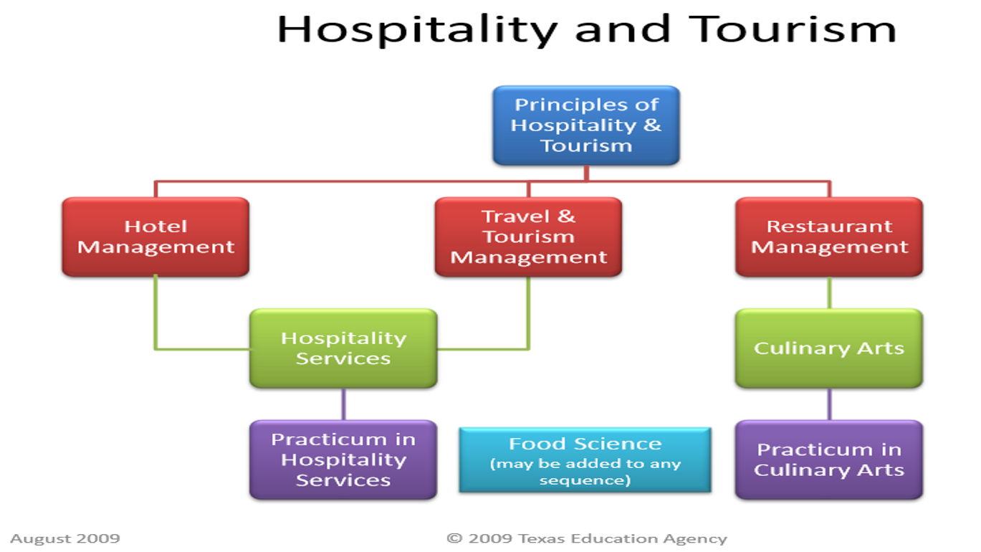

**16**

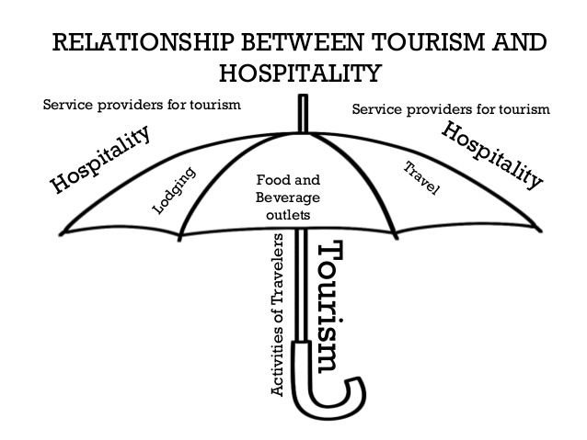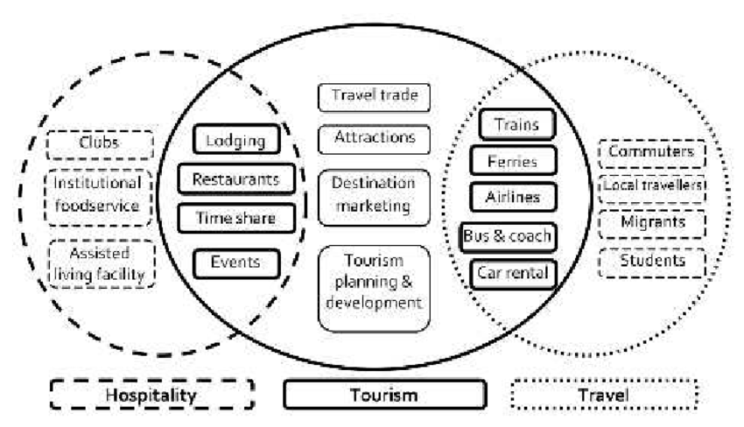

**17**

* **THE END -**